Expense Categorization Tool
AI-Powered Financial Insights and Analysis

Project Description
The Expense Categorization Tool is an intelligent financial management platform that leverages advanced AI to provide comprehensive expense analysis and categorization. The platform addresses the challenge of unorganized financial records by delivering AI-powered insights, detailed spending breakdowns, and visual reports to improve financial awareness and budgeting habits.
Using cutting-edge AI models, the system analyzes transaction data from CSV files or Google Sheets, automatically classifying expenses into meaningful categories like Food, Travel, Shopping, and Utilities. The system ensures high accuracy through sophisticated AI analysis and data processing algorithms, allowing users to identify spending patterns and optimize their financial health.
The Expense Categorization Tool transforms financial tracking into an intelligent, user-friendly experience through its modern interface, comprehensive feature set, and AI-powered analysis that provides personalized budgeting guidance. By automating the tedious task of manual categorization, the tool helps users make smarter financial decisions and maintain better control over their expenses.

Scenarios
Scenario 1 – Personal Budgeting:
A university graduate starting their first job wants to manage their salary effectively but finds manual tracking overwhelming. By uploading their monthly bank statements to the Expense Categorization Tool, the AI automatically groups transactions into categories like 'Rent', 'Groceries', 'Dining Out', and 'Transport'. The user receives a visual breakdown that highlights excessive spending in 'Entertainment', enabling them to adjust their habits and meet their savings goals for the month.
Scenario 2 – Small Business Expense Tracking:
A small retail business owner needs to organize hundreds of supplier payments and utility bills for annual tax filing. Instead of spending days on manual entry, they upload their transaction history. The tool identifies and categorizes 'Inventory Purchases', 'Utilities', 'Marketing', and 'Payroll'. This provides a clear financial overview for their accountant, ensuring maximum tax deductions and compliance with financial regulations.
Scenario 3 – Freelance Travel Management:
A freelance consultant travels frequently for various clients and needs to separate billable expenses. The tool categorizes trip-related costs like 'Airfare', 'Hotel stays', and 'Client Meals'. The consultant can then generate specific reports for each client, streamlining the reimbursement process and maintaining professional financial records without the hassle of manual spreadsheet management.
Scenario 4 – Family Financial Oversight:
A family of four uses the tool to monitor their shared household expenses. The AI identifies recurring subscription costs and highlights a significant increase in 'Utilities' compared to the previous month. This insight prompts the family to investigate a potential water leak and cancel unused streaming services, leading to substantial annual savings and better overall financial planning.

Architecture Overview
The Expense Categorization Tool is built as a modular platform combining a robust Python/Flask backend with a modern React/Vite frontend. The architecture prioritizes data integrity, processing efficiency, and a seamless user experience by leveraging AI-driven categorization and dynamic data visualization.

Core Technologies
- Python & Flask: Lightweight and efficient backend for routing and API management.
- AI Model Integration: Advanced natural language processing for intelligent transaction classification.
- React.js: High-performance frontend library for building interactive user interfaces.
- Vite: Ultra-fast build tool and development server for modern web projects.
- Pandas & NumPy: Powerful data analysis libraries for processing complex CSV structures.
- CSS & Tailwind: Modern styling for a responsive and premium visual experience.
- Chart.js/Matplotlib: Dynamic charting for visual financial reports and insights.

Pre-requisites

Software Requirements
- Python 3.8+: Core programming language for backend development.
- Node.js & npm: Essential for managing frontend dependencies and build tools.
- Git: Version control for tracking project development and collaboration.
- OpenAI API Key: Required for accessing advanced AI categorization models.
- Postman: For testing and validating backend API endpoints.
- Modern Web Browser: For interacting with the frontend application.

Knowledge Prerequisites
- Python Programming: Proficiency in Flask and data handling libraries.
- JavaScript & React: Understanding of component-based UI development.
- API Integration: Experience with RESTful services and AI model interaction.
- Financial Literacy: Basic understanding of expense categories and budgeting.
- Data Management: Skills in handling and cleaning CSV/Excel data.

Hardware Requirements
- Processor: Dual-core 2.4GHz or better (Intel i5/AMD Ryzen 5 recommended).
- RAM: 8GB minimum (16GB recommended for smooth development).
- Storage: 10GB free space for project files and dependencies.
- Internet Connection: Stable connection for API calls and package management.

Project Workflow

Phase 1: Environment Setup & Project Initialization
Establish the development infrastructure and configure core services.
Activity 1.1: Set up Development Environment
- Initialize Python virtual environment and install backend dependencies.
- Set up Node.js environment and initialize Vite project for the frontend.
- Configure environment variables and secure API key storage.
Activity 1.2: Project Architecture Design
- Define the backend directory structure and Flask application entry point.
- Design the frontend component hierarchy and state management strategy.
- Establish Git repository and branch management workflow.

Phase 2: Backend & AI Engine Development
Build the core processing logic and integrate AI models.
Activity 2.1: Implement Data Upload & Parsing
- Create Flask routes for secure CSV and Excel file uploads.
- Develop data cleaning scripts using Pandas to handle inconsistent formats.
- Implement error handling for malformed or missing transaction data.
Activity 2.2: AI Categorization Logic
- Design prompts for the AI model to accurately classify transaction descriptions.
- Implement API calling logic with retry mechanisms and timeout handling.
- Build a fallback rule-based system for common or high-confidence categories.

Phase 3: Frontend & Dashboard Development
Create a responsive user interface and interactive visualizations.
Activity 3.1: Design Core UI Components
- Develop the transaction list view with filtering and sorting capabilities.
- Build the file upload interface with real-time progress indicators.
- Create user authentication screens for secure data access.
Activity 3.2: Interactive Data Visualization
- Integrate Chart.js to display category-wise spending breakdowns.
- Develop monthly trend charts and budget comparison widgets.
- Implement interactive tooltips and detailed drill-down reports.

Phase 4: Integration & System Testing
Ensure seamless communication between components and validate accuracy.
Activity 4.1: End-to-End Testing
- Verify the full flow from file upload to AI categorization and UI display.
- Conduct cross-browser compatibility testing for consistent experience.
- Perform load testing with large datasets to ensure system stability.

Phase 5: Deployment & Final Documentation
Activity 5.1: Final Deployment & Review
- Deploy the application to a cloud provider or local production server.
- Perform final security audits and API performance tuning.
- Generate comprehensive user manuals and technical project reports.

Technical Architecture
The technical architecture of the Expense Categorization Tool follows a modern decoupled approach.

Project Structure
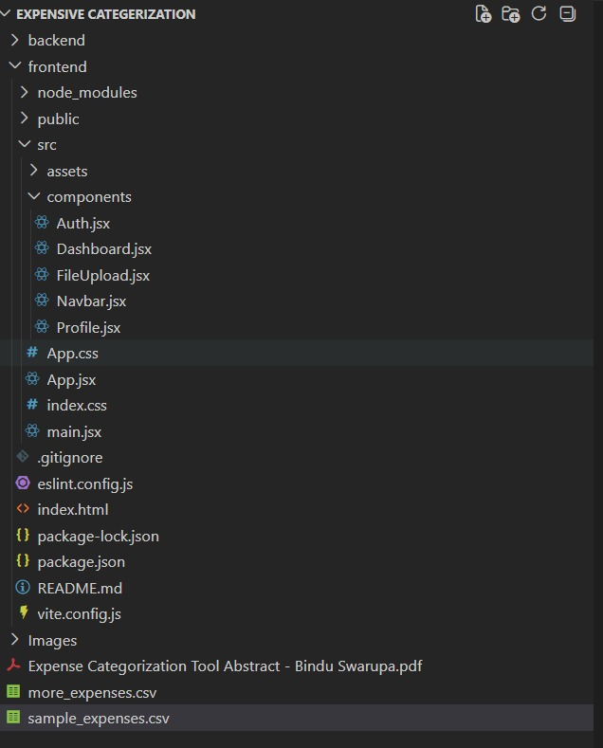
Detailed Project Directory Structure
The project structure is meticulously organized into backend and frontend directories. The 'backend' folder contains the Flask application, API routes, and data processing logic. The 'frontend' folder houses the React components, assets, and styling configurations. This separation ensures a scalable and maintainable codebase, allowing for independent development and deployment of both components.

MILESTONE 1: Environment Setup & Requirements
This initial milestone focuses on defining the project scope and setting up the development environment.
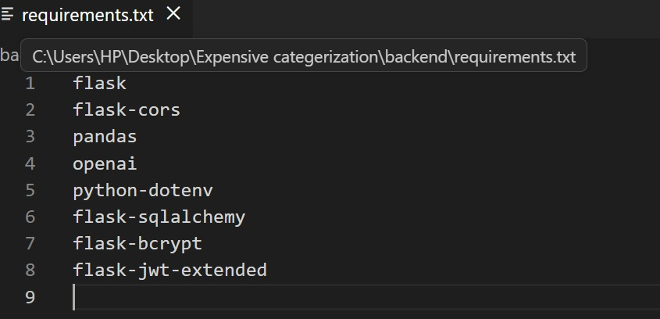
Activity 1.1: Project Requirements Gathering
The requirements document outlines the functional and non-functional specifications of the tool. It includes details on data privacy, AI model selection, and the desired user experience milestones.
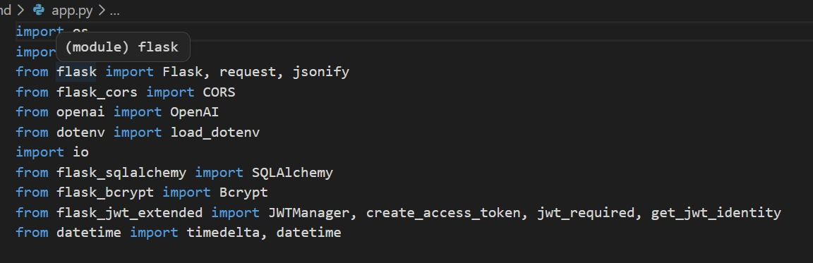
Activity 1.2: Dependency Installation
Installing the core libraries such as Flask for the backend and React for the frontend. All dependencies are tracked in requirements.txt and package.json to ensure environment consistency.

MILESTONE 2: Core Backend Development
Development of the backend infrastructure and AI processing engine.
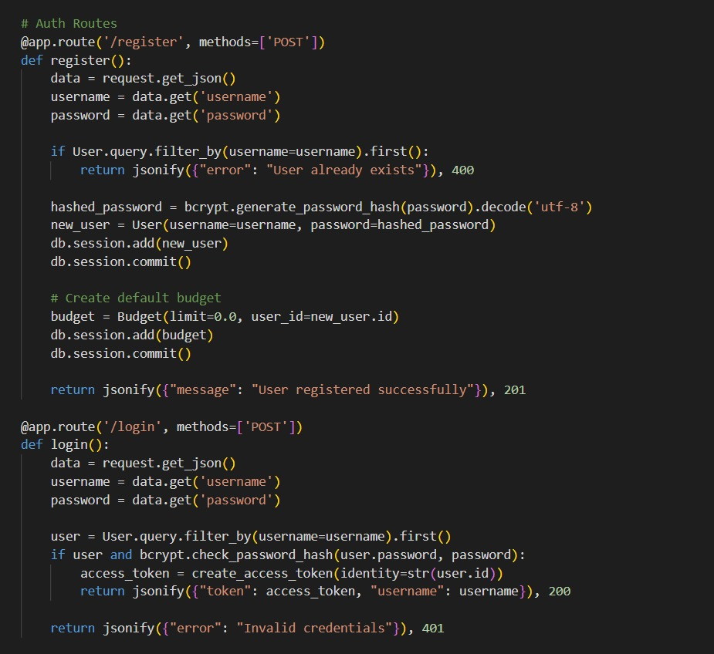
Backend Activity
Backend API Configuration: Setting up the Flask application and defining the initial API routes for data handling.
This component is critical for ensuring that the application can handle various data formats and provide accurate, real-time results to the end user. The backend serves as the bridge between the raw data and the intelligent insights provided by the AI model.

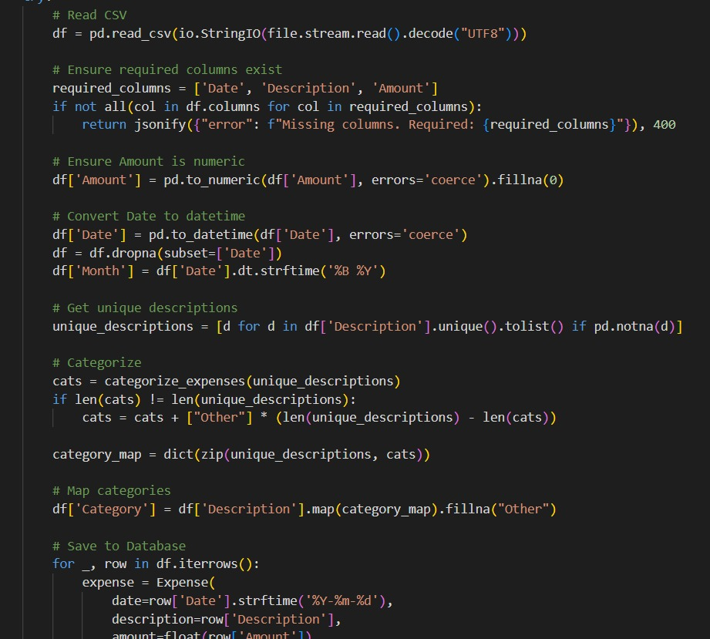
Backend Activity
AI Categorization Engine: Implementation of the core logic that communicates with the AI model to classify expenses.
This component is critical for ensuring that the application can handle various data formats and provide accurate, real-time results to the end user. The backend serves as the bridge between the raw data and the intelligent insights provided by the AI model.

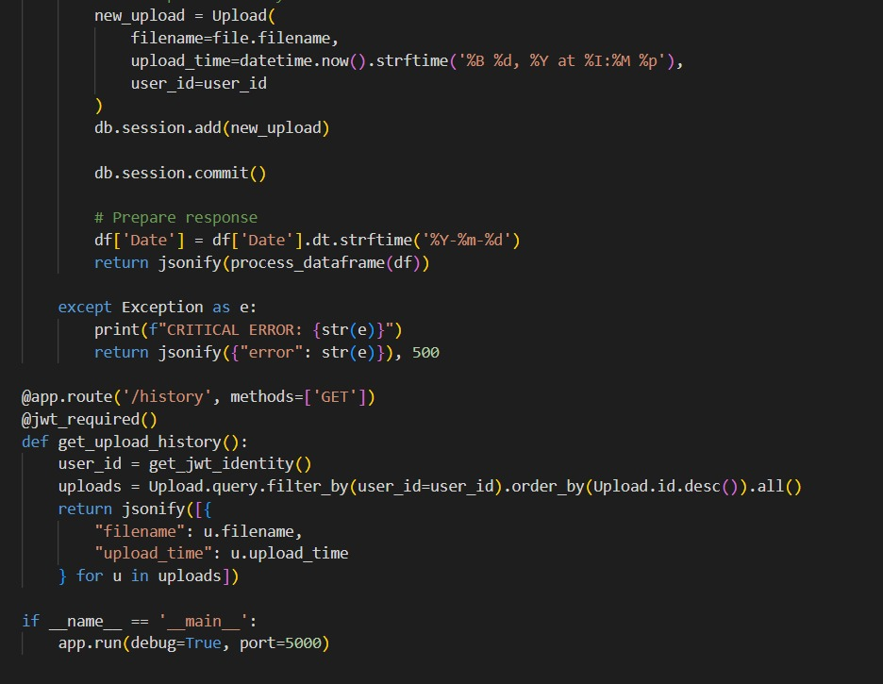
Backend Activity
Data Processing Logic: Developing the Pandas-based engine for cleaning and structuring uploaded transaction data.
This component is critical for ensuring that the application can handle various data formats and provide accurate, real-time results to the end user. The backend serves as the bridge between the raw data and the intelligent insights provided by the AI model.

MILESTONE 3: Frontend Development
Designing and building the interactive user interface for the Expense Categorization tool.
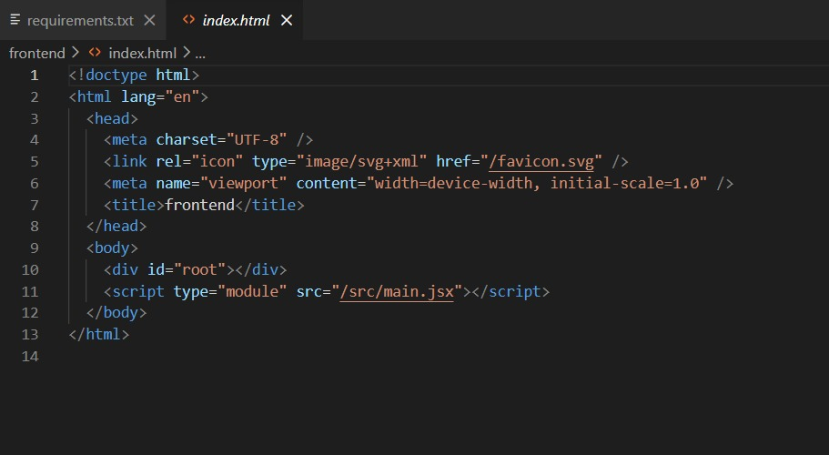
Frontend Activity
Main Application Entry: The entry point of the React application, managing global state and routing.
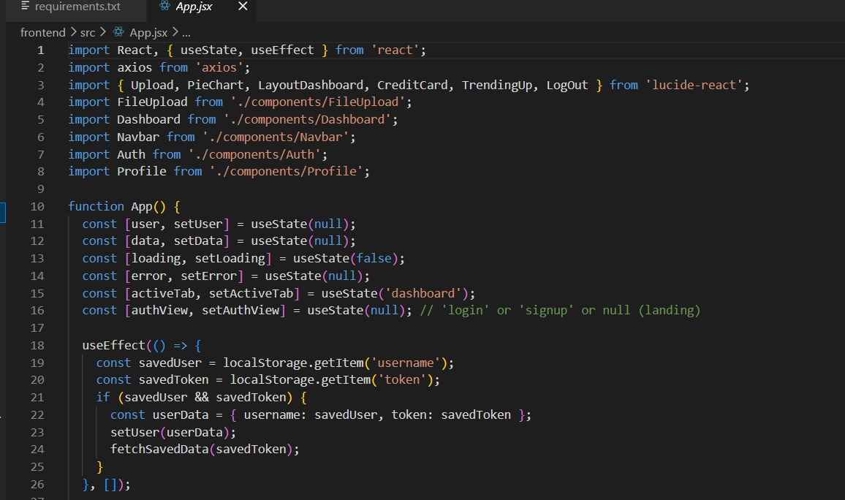
Frontend Activity
Dashboard Component: Implementation of the primary dashboard view with summary widgets.

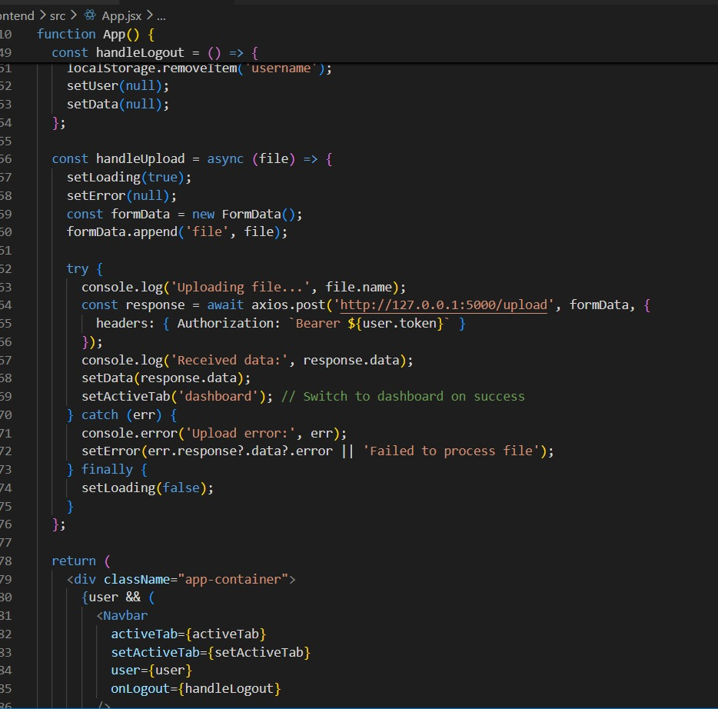
Frontend Activity
Transaction List View: Building the interactive table for displaying and filtering transactions.

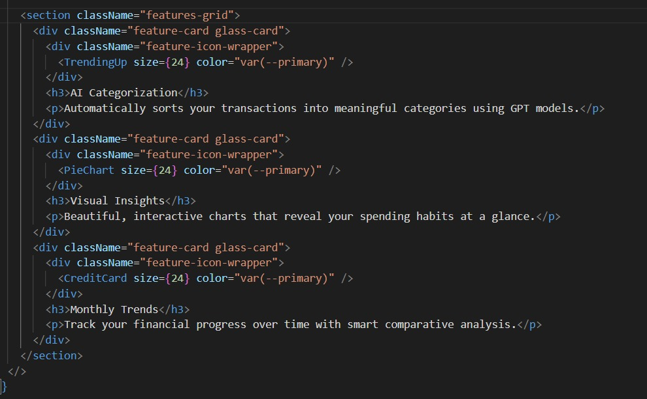
Frontend Activity
Upload Interface: Creating the user-friendly drag-and-drop interface for financial data files.
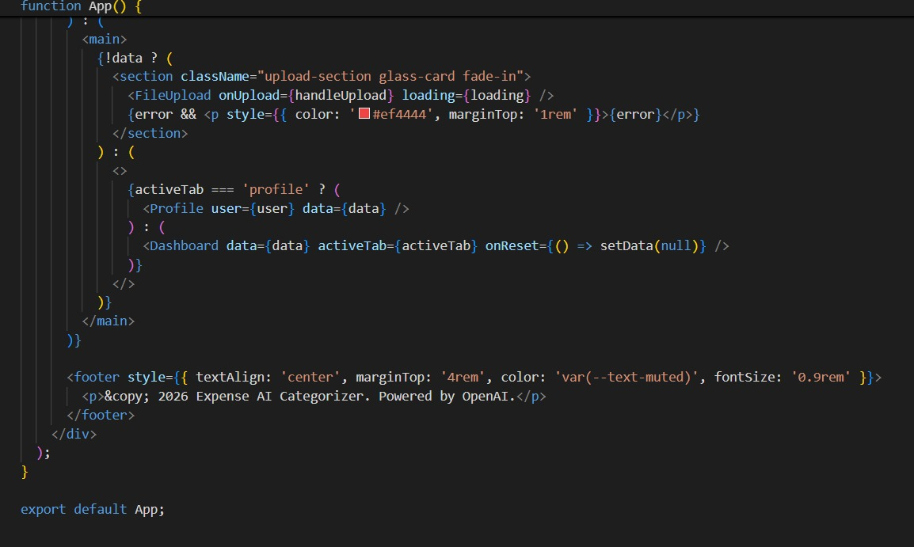
Frontend Activity
AI Insights Display: Developing the component that renders intelligent financial advice from the AI model.
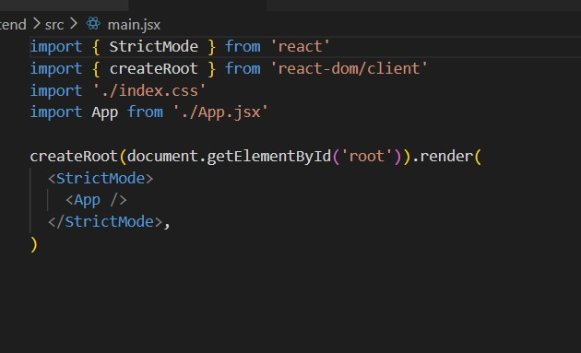
Frontend Activity
React Component Architecture: Overview of the modular component structure used in the frontend.

MILESTONE 4: Deployment & Final Results
Deploying the application and verifying the final output of the categorization tool.

Deployment Environment Setup
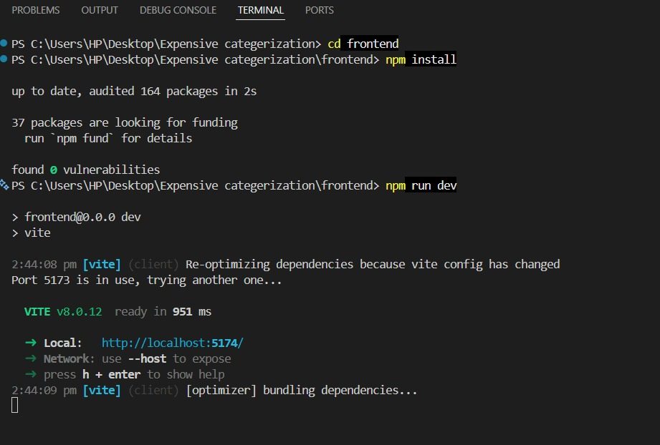
Activity 4.1: Backend Server Deployment
Verification of the Flask server starting up and listening for incoming API requests.
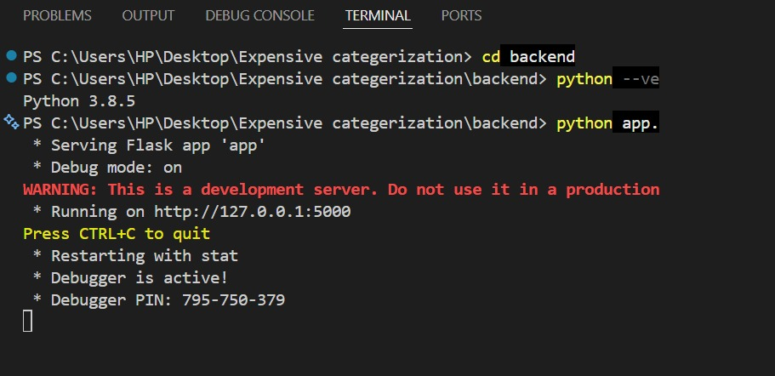
Activity 4.2: Frontend Development Server
Confirming the Vite development server is running and the frontend is accessible via the browser.

Final Application Results:
HOME PAGE:
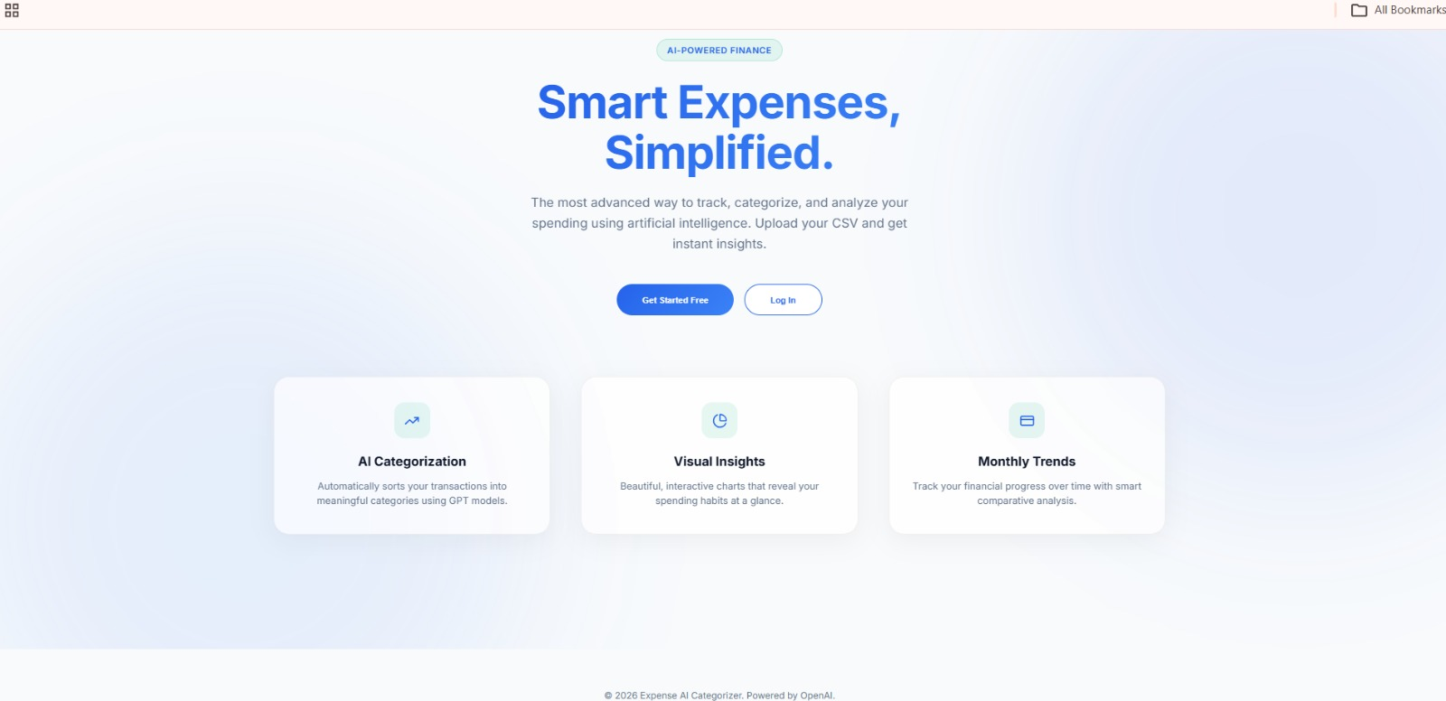
Application Landing Page: The professional entry point for users to access the tool.
The final results demonstrate the tool's effectiveness in transforming raw transaction data into clear, categorized financial insights. The combination of accurate AI classification and intuitive visualization provides users with a powerful tool for personal finance management.
LOGIN PAGE:

Secure Login Interface: Authentication screen ensuring user data privacy and security.
The final results demonstrate the tool's effectiveness in transforming raw transaction data into clear, categorized financial insights. The combination of accurate AI classification and intuitive visualization provides users with a powerful tool for personal finance management.
SIGN UP PAGE:
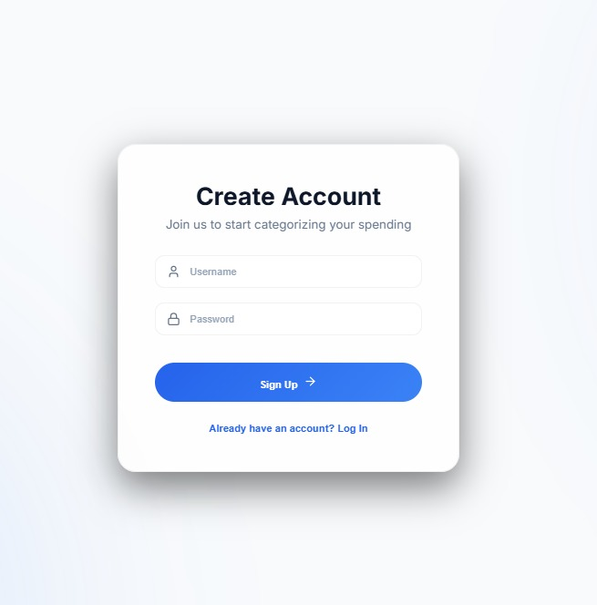
User Registration: New user onboarding process for personalized financial tracking.
The final results demonstrate the tool's effectiveness in transforming raw transaction data into clear, categorized financial insights. The combination of accurate AI classification and intuitive visualization provides users with a powerful tool for personal finance management.

Dashboard Page:
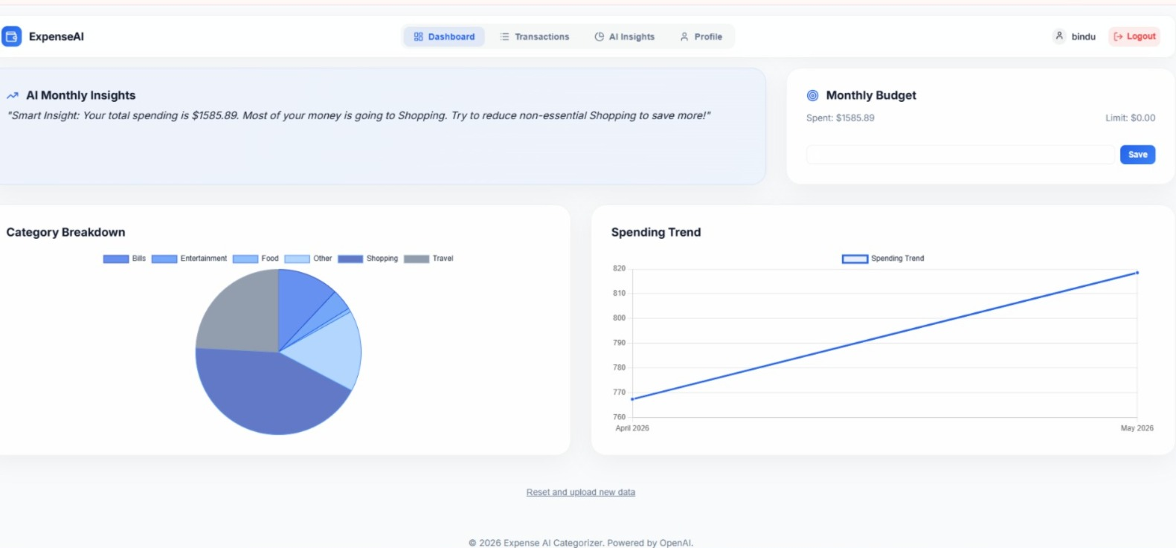
Main Dashboard Overview: Visual summary of categorized expenses and spending trends.
The final results demonstrate the tool's effectiveness in transforming raw transaction data into clear, categorized financial insights. The combination of accurate AI classification and intuitive visualization provides users with a powerful tool for personal finance management.
File Upload:
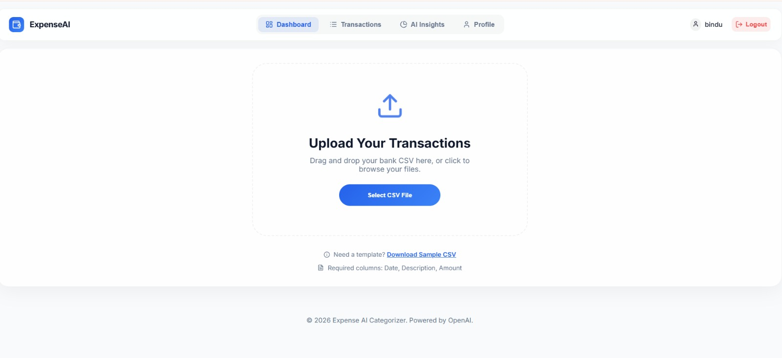File Upload Portal: Easy interface for importing transaction data from external files.

Upload Sucessfull:
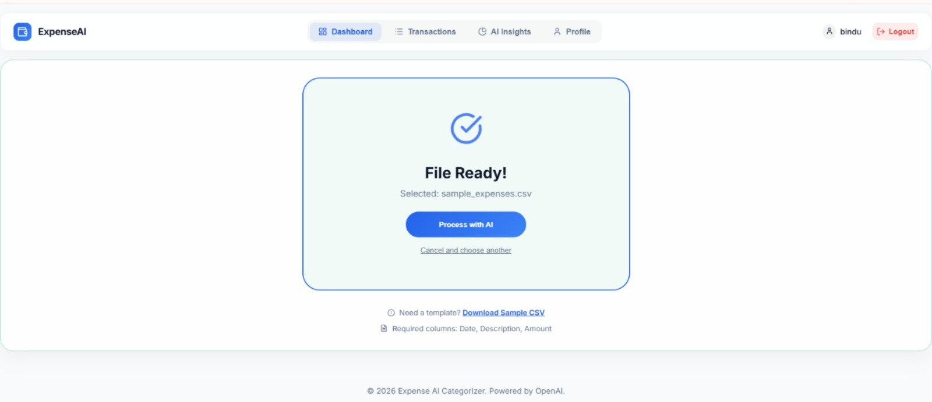
Data Processing Confirmation: Real-time feedback after successfully parsing transaction files.
The final results demonstrate the tool's effectiveness in transforming raw transaction data into clear, categorized financial insights. The combination of accurate AI classification and intuitive visualization provides users with a powerful tool for personal finance management.
Transaction Data:
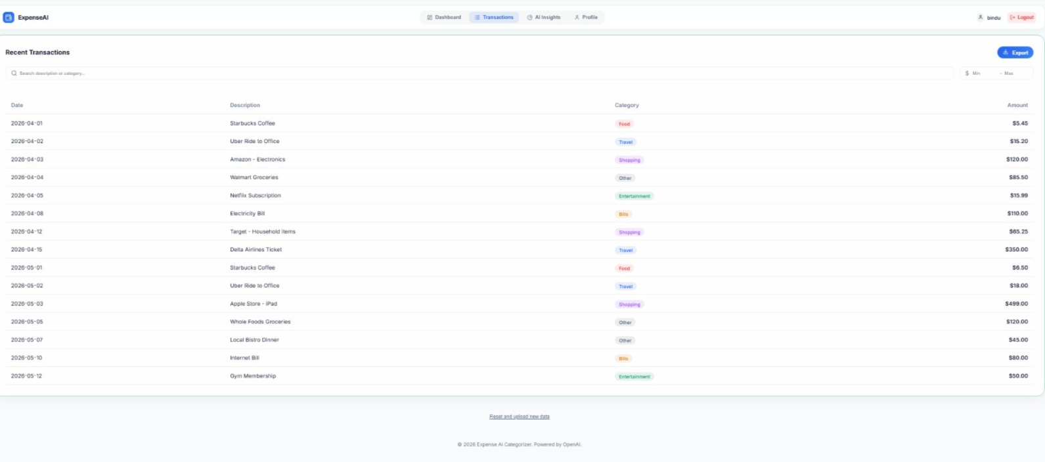
Detailed Transaction View: Comprehensive list of categorized transactions with manual override options.
The final results demonstrate the tool's effectiveness in transforming raw transaction data into clear, categorized financial insights. The combination of accurate AI classification and intuitive visualization provides users with a powerful tool for personal finance management.

AI Insights:
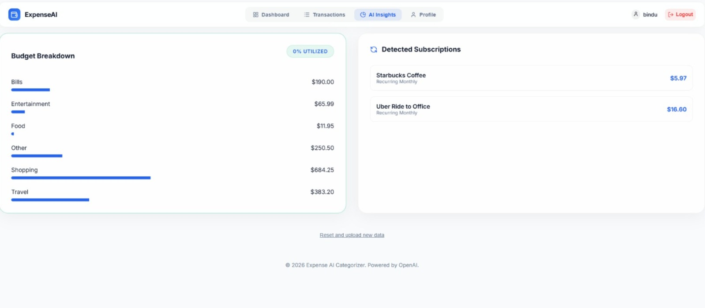
Intelligent Financial Reports: AI-generated advice and detailed spending analysis.
The final results demonstrate the tool's effectiveness in transforming raw transaction data into clear, categorized financial insights. The combination of accurate AI classification and intuitive visualization provides users with a powerful tool for personal finance management.
Profile:
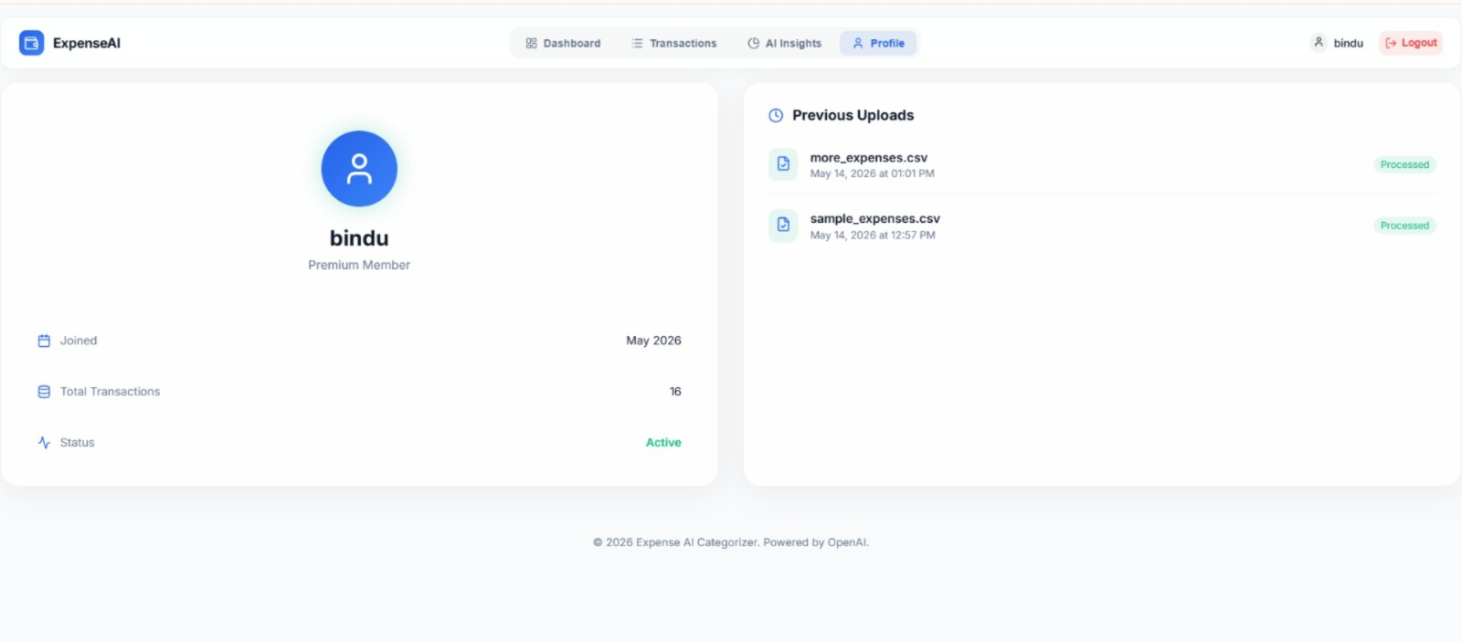
User Profile Management: Settings for managing account details and financial preferences.
The final results demonstrate the tool's effectiveness in transforming raw transaction data into clear, categorized financial insights. The combination of accurate AI classification and intuitive visualization provides users with a powerful tool for personal finance management.

Conclusion
The Expense Categorization Tool successfully provides an automated, AI-driven solution for managing complex financial records. By integrating a robust Flask backend with a modern React frontend, the application delivers high accuracy in transaction classification and a premium user experience.
The project milestones demonstrate the systematic development process, from environment setup to final deployment and result validation. This tool serves as a powerful example of how AI can be applied to everyday financial tasks, helping users gain better control over their spending and build a more secure financial future.

